Name – Manan Madan

Roll No - 2018UIC3087

Q. 1 Explain in detail the storage and erasure mechanism of an EEPROM cell.

EPROM (UV Erasable Programmable Read Only Memory) is a special type of ROM that is programmed electrically and yet is erasable under UV light. The EPROM device is programmed by forcing an electrical charge on a small piece of polysilicon material (called the floating gate) located in the memory cell. When this charge is present on this gate, the cell is “programmed,” usually a logic “0,” and when this charge is not present, it is a logic “1.” Figure below shows the cell used in a typical EPROM. The floating gate is where the electrical charge is stored.

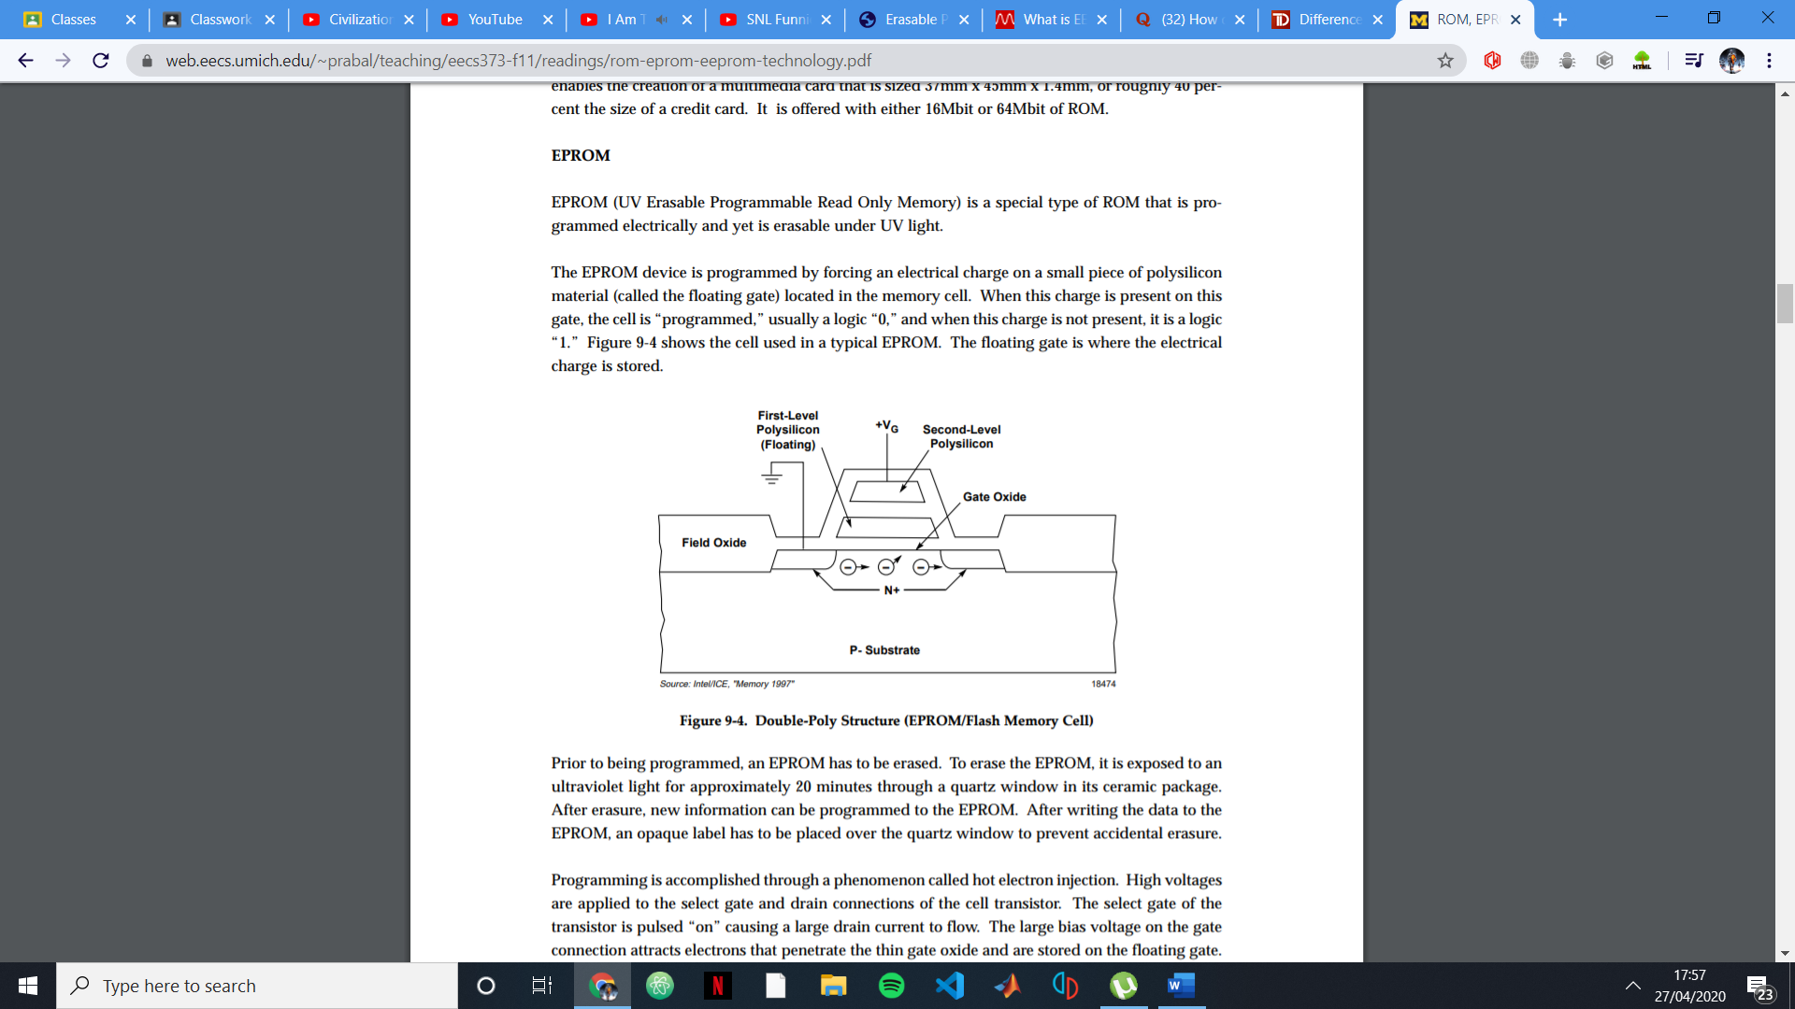

Prior to being programmed, an EPROM has to be erased. To erase the EPROM, it is exposed to an ultraviolet light for approximately 20 minutes through a quartz window in its ceramic package. After erasure, new information can be programmed to the EPROM. After writing the data to the EPROM, an opaque label has to be placed over the quartz window to prevent accidental erasure.

Programming is accomplished through a phenomenon called hot electron injection. High voltages are applied to the select gate and drain connections of the cell transistor. The select gate of the transistor is pulsed “on” causing a large drain current to flow. The large bias voltage on the gate connection attracts electrons that penetrate the thin gate oxide and are stored on the floating gate.

There are two ways to erase the EEPROM. This can be done using the standard mode erasing algorithm which includes defined delays, or the AUTO mode erasing algorithm can be employed. In the AUTO mode, there are no fixed delays, and instead the EEPGM bit is polled. When the bit is cleared, the erasing has been completed.

# EEPROM Standard Mode Erasing Algorithm

1. Write the BULKP, BYTE, and ROW bits in the EEPROM control register (EEPROG) to specify the erase size. Set the ERASE bit to specify erasing operation. Set the EELAT bit to control erasing latches.

2. Write a byte of data to an EEPROM address OR write a word of data to a word-aligned EEPROM address. If the erase operation is not erasing the entire array or a full row, then this write determines whether a single byte or a word will be erased. Therefore, the address written to must be within the desired erase block.

3. Set the EEPGM bit. Apply erasing voltage to the EEPROM.

4. Wait tERASE. tERASE is the high voltage hold time for erasing.

5. Clear the EEPGM bit. Disable the erasing voltage from the array.

6. Clear the EELAT bit. Set the EEPROM into the normal mode.

# EEPROM AUTO Mode Erasing Algorithm

1. Write the BULKP, BYTE, and ROW bits in the EEPROM control register (EEPROG) to specify the erase size. Set the ERASE bit to specify erasing operation. Set the EELAT bit to control erasing latches. Set the AUTO bit for automatic erasing time termination. See Table 6 for a description of the BULKP, BYTE, and ROW bits.

2. Write a byte of data to an EEPROM address or write a word of data to a word-aligned EEPROM address. If the erase operation is not erasing the entire array or a full row, then this write determines whether a single byte or a word will be erased. Therefore, the address written to must be within the desired erase block.

3. Set the EEPGM bit. Apply erasing voltage to the EEPROM.

4. Poll the EEPGM bit until it is cleared by the internal timer.

5. Clear the EELAT bit. Set the EEPROM into the normal mode.

